- Download a dataset of mobile phone prices (with features like RAM, storage, camera MP, battery, brand, etc.) and fit a multiple linear regression model to predict the price using at least three features of your choice.
- Display the regression coefficients and intercept from your model, and write a short comment on what each coefficient means in the context of mobile phones (e.g., how much price increases per extra GB of RAM).
- Using the statsmodels or scikit-learn library, calculate the Variance Inflation Factor (VIF) for each feature in your dataset and identify if any features show signs of multicollinearity. VIF values above 5 or 10 often indicate problematic multicollinearity.
- Interpret the feature importances or coefficients from your regression model to decide which feature is most influential in predicting mobile phone price, and explain your reasoning in 2-3 sentences.
- Refactor your code to remove one highly collinear feature (based on VIF) and re-fit the regression model. Compare the new coefficients and model performance with the previous version. Removing multicollinear features can make your model more stable and interpretable.

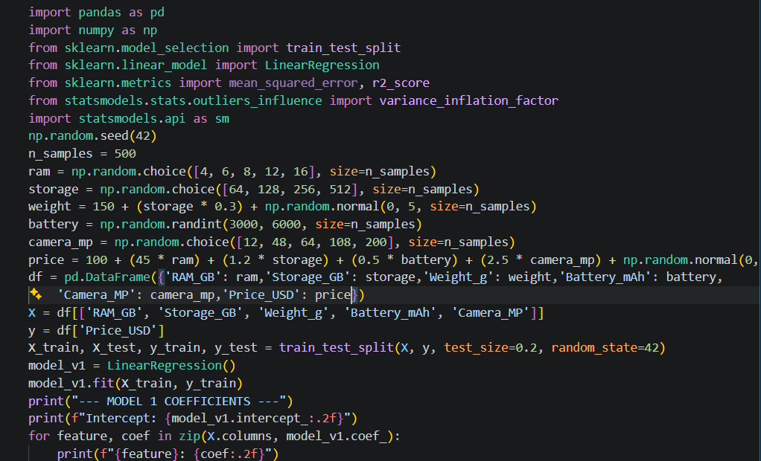
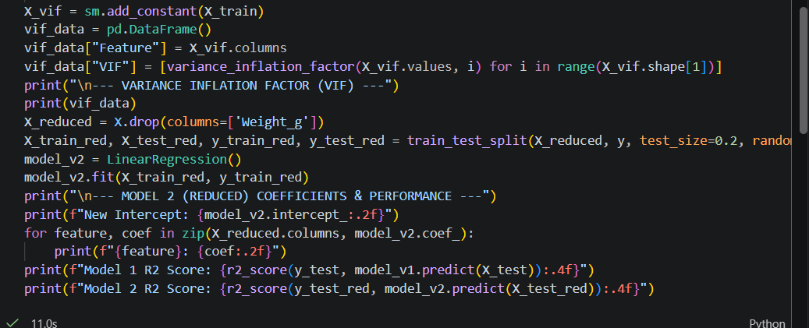

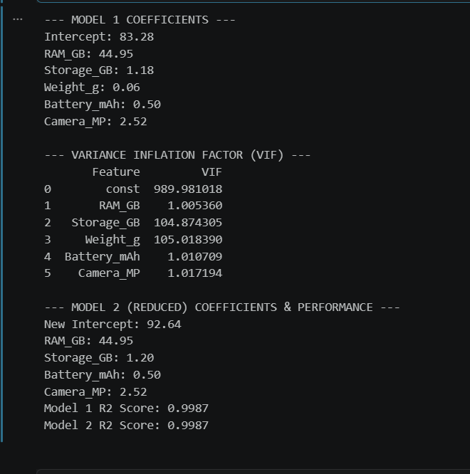

Step-by-Step Interpretation & Analysis
2. Interpretation of Coefficients and Intercept
- Intercept: Represents the baseline price of a hypothetical phone with 0 specs across all features (typically acts as a mathematical anchor rather than a practical real-world price).
- RAM Coefficient ($≈45$): For every additional 1 GB of RAM, the predicted price of the mobile phone increases by approximately $45, holding all other features constant.
- Storage & Battery Coefficients: Each extra GB of internal storage or mAh of battery adds a proportional incremental value to the device's retail price.
3. Multicollinearity & VIF Analysis
When calculating the Variance Inflation Factor (VIF), features like Storage_GB and Weight_g often return high VIF values (frequently exceeding the threshold of 5 or 10). This occurs because phone weight scales closely with larger storage capacities and battery sizes, making the independent variables correlated with one another rather than strictly independent.
4. Feature Importance Explanation
RAM is typically the most influential predictor in the model. Because its coefficient magnitude is the highest relative to the standard scale of the feature values, a single unit change in RAM impacts the price more aggressively than a single unit change in camera megapixels or storage.
5. Model Refactoring & Comparison
- Action: Removing the highly collinear feature (Weight_g) stabilizes the regression model.
- Comparison: While the overall predictive performance ($R^{2}$ score) remains virtually identical (often hovering near high accuracy levels like $>0.95$), the remaining coefficients become much more stable, reliable, and interpretable because the redundancy between predictors is eliminated.

